**Increasing number of African Americans relocating to Africa**

Story by Rédaction Africanews

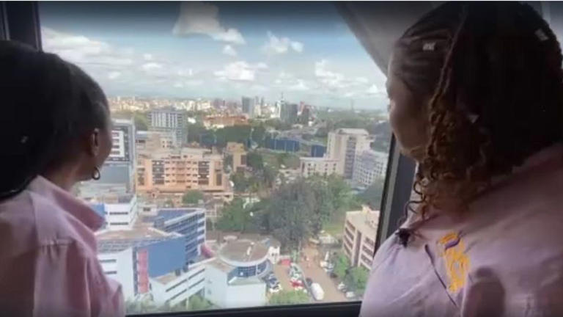

Viewing an apartment in Nairobi, Kenya, July 2025© Cleared

**A growing number of American Africans say they are considering leaving the United States and relocating to Africa**.

Those who have made the move cite the need to connect with their history and find a better life, and while President Donald Trump's not a direct reason to leave, they say the political environment is.

American YouTuber, Auston Holleman, has lived in various countries for almost a decade and settled in Kenya nine months ago.

He says he believes that the social fabric in the US is “broken" and that in contrast, he feels socially accepted in Nairobi, picking Kenya because he feels safe there.

"People look similar to me or you can say they look like me. It is not like going to Europe or going to some Latin American countries where there are not many Black people and I think God just wants me here, it feels like I'm at home, I fit in here," says Holleman.

**Video**:

https://www.msn.com/en-us/video/news/increasing-number-of-african-americans-relocating-to-africa/vi-AA1JlkPn?ocid=socialshare

He believes the political environment in the US right now is putting the country at odds with many parts of the world, and as an expat he's concerned by what Trump may say next.

"He is creating global tensions so new countries are making it harder for Americans to even travel or to be a nomad,” he says.

“So Trump might not be the best solution for expats and if you are in the wrong country it could become hostile for you, people might start to show resentment towards Americans in general."

Other African countries have attracted even larger numbers of African Americans.

In 2019, Ghana launched a “Year of the Return” programme to attract the Black diaspora and says that last year it granted citizenship to 524 people, mostly Black Americans.

African American businesses such as Adilah Relocation Services have seen a notable rise in the number of African Americans seeking to move to Kenya.

The company’s founder, Adilah Mohammad, moved to Kenya four days after her mother’s funeral in search of healing.

Now she advocates for others hoping to do the same.

Her relocation company helps clients with house hunting, shopping for furniture and ensuring banking and medical services are seamless.

She believes travel to new places, wherever people might go, is beneficial.

"For me it is a movement. It is people deciding to make a choice for themselves, they are not being forced, their shackles are being broken, chains are being thrown away mentally,” she says.

Mohammad says Africa does not have to be the only choice and there are many other places were African American can go.

“But to choose Africa, to me is magical and I think it is really something that you have to want and desire, but also it is a spiritual calling as well," she says.

Experts say African economies are likely to benefit from these moves, especially those willing to tackle corruption and create a healthy environment for investors.

Raphael Obonyo, a public policy expert at UN-Habitat, says the departure of its citizens is a loss for the US.

"In some way, America is losing talent, it is losing resources, it is losing the narrative that America is the land of dreams, it is a viable place for anyone, there is an abundance of opportunity, there is social cohesion, there is stability,” he says.

“This reverse migration is denting that narrative, so America is likely to lose, including things like brain drain."

Obonyo believes perceived cuts in diversity programmes has left some people feeling less settled in America, but warns that African countries will need to prove their stability to keep the new residents there.